Passion and purpose

God’s purpose for everyone
God has plans and a purpose for each of our lives. For all Christians, our purpose in life includes worship, fellowship, discipleship, ministry and mission.  God’s unique purpose for you | For I know the plans I have for you,"  declares the LORD,  "plans to prosper you and not to harm you,  plans to give you hope and a future.  Jeremiah 29:11
But God has also made each of us different. This workshop is to help you explore God’s unique purpose for your life.  Life’s No 1 decision is not:  - Where shall I live  - Who shall I marry  - Where to work  But “How does God want to use my life  to make a difference in the world” | Make a careful exploration of who you are  and the work you have been given  and sink yourself into that.  Don’t be impressed with yourself.  Don’t compare yourself with others  Each of you must take responsibility for doing  the creative best you can with your own life.  Galatians 6:4-5 (The Message)
What is a “passion and purpose”?  Your “passion and purpose” might be a group of people, an issue or a cause, or an activity. It could be at home, in the workplace, among your friends, at church, abroad or in cyberspace. It might not appear particularly spiritual, but it could be God at work nonetheless.  Other words some of you may have used for the passion and purpose that God puts in your heart are dream, burden, vision or calling. | Eric Liddell, in “Chariots of Fire” said:  “God made me for a purpose  and that purpose was China  but he also made me fast  and when I run I feel his pleasure”

Example passions
Here are the passions of a few people who have done this workshop previously
“Children under six”
“Counteracting prejudice and the resulting social injustice”
“Discipling the youth”
“Bringing hope and meaning to people who previously had none”
“Making things”
“To help people find deeper reality”
“To get into God and get God into others”
“Helping people understand”

Active Listening Process
It is not always easy to work out what God wants. But there are a number of clues that he has given us. This active listening process is designed to help you gain a clearer sense of God’s call on your life.

- Answer the questions and sections in any order, as ideas come to mind. Leave out any that seem unhelpful.
- Go through the worksheet on your own
- It doesn’t have to be neat!
- There are no right or wrong responses
- It is not important to finish all the questions during the workshop time.
- Don’t be concerned about ‘whether’ you can do it or ‘how’ it can be done
- Write down ideas as if you have no obstacles to fulfilling your heart’s desire

* Passions  Listen for God’s voice through the passions he has put in your heart.  - What conversation would keep you talking late into the night?  - If your name was mentioned to a group of your friends, what would they say you were really interested in or passionate about?  - What are the issues or causes you feel strongly about? | “Passions  are about  God capturing  our imagination,  stirring our  deep feelings  and calling us  into action”.
* Your past  Listen for God’s voice in your past.  - List your top five positive experiences of doing something for others.  - When did you really come alive?  - What heroes inspired you.  - What did God say to you when you were young? | “Don’t ask what  the world needs,  ask what makes  you come alive  and do that,  because what  this world needs  is people who  have come alive”
* Needs of others  Listen for God’s voice through the needs of others.  - Underline the groups of people you would most like to help.  - What human needs tear at your heart, locally and globally? | Children, Youth, Single parents, Students, Divorced, Widowed, Singles, Married, Refugees, Parents, Poor, Homeless, Hospitalised, Elderly, Disabled, Prisoners, Unemployed  Mother Teresa said “Jesus is often thinly disguised in the poor and suffering in our midst”

* Gifts and talents
Listen for God’s voice in your talents and spiritual gifts

- What are you good at doing?
- Where have you noticed God working through you?

(there is another workshop to help you identify spiritual gifts)
* Dreams  Listen for God’s voice through your dreams  - Do you have a vision for how things could be different?  - Can you recall a night-time dream that might have been God prompting you?  - If you ruled the world, what would you change?  - At the end of your life, what would you love to be able to look back and know that you’d done something about?  - Write an epitaph for your own gravestone. | Martin Luther King  “I have a dream…”

* Scripture
Listen for God’s voice through scripture. Read the Bible regularly. Note what seems important. Look for themes

- Do you have extra-special verses or a Bible character you identify with?
- What are the Kingdom themes in that verse or story?

* Prayer  Listen for God’s voice through prayer. Pray for situations of need. You might become part of the answer.  - What things often crop up in your prayers? | “The place  God calls you to  is the place  where your  deep gladness  and the world’s  deep hunger  meet”

* Moving into the Kingdom
This diagram illustrates some of the blessings that happen when people encounter the Kingdom of God. For example, near the top of the diagram, you can see that people are able to move from being rejected and unloved to being accepted by God.
- Circle any words that remind you of your own journey of faith.
- Circle any words that describe the kinds of people you would most like to help.

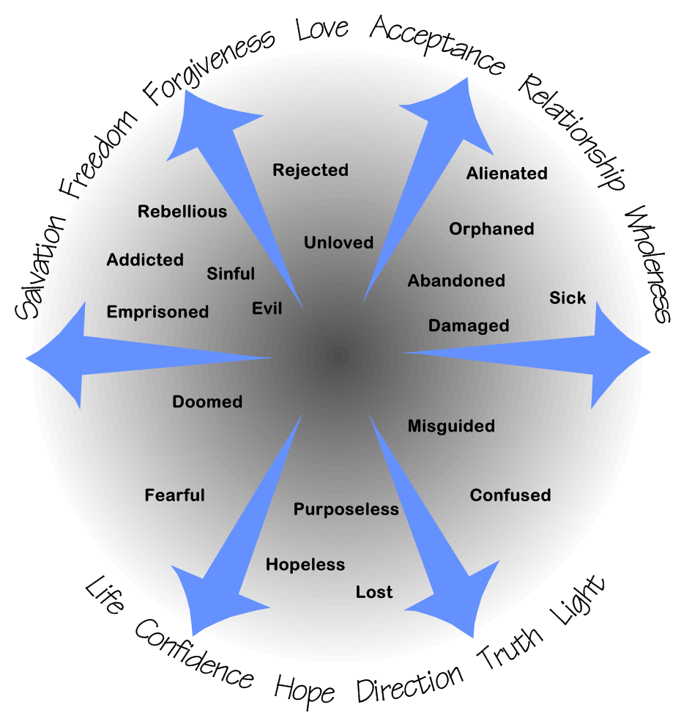

Questions 9-12 require a little more time. In the workshop setting, skip to “Looking for patterns”

Roles
Listen for God’s voice through exploring each of your roles – work, home, church, sport, community.

- For each one, complete the sentence: “In this area, I want (and God wants me) to be a ……”

Broken places
Listen for God’s voice through the broken places in your life. Charles Colson started Prison Fellowship following his involvement in the Watergate scandal. Joni started her singing, art, teaching and ministry to disabled following a quadraplegia accident. In your weakness he is strong.

- What areas of failure, trauma, brokenness, addiction or disability have you been through in your life?
- What bumpy times have you had on your spiritual journey?

(You may wish to answer these in private after the workshop)

Stillness
Retreat from distractions – remove busyness, television, people. Take your journal and a Bible. e.g. Northumbria community. A real challenge with kids – offer spouse a weekend day away. Listen for God’s voice in stillness – silence and Bible meditation. Release pressures – write on a list. Worship. Be thankful. Wait

- Note down anything you think God might be saying in the stillness

Imagination
Listen for God’s voice through your imagination.

- Brainstorm practicalities around biblical purposes
- Listen for God’s voice through picturing new possibilities – art and visualisation

Looking for patterns
It often helps to talk about your passions as well as writing them down.
For the next section, get together with one other person.

Concentrating on one person at a time:
- Read aloud or show what that person has written to the questions they have tackled.
- Pick out (underline or circle) key words.
- Try to clarify what they mean e.g. “What sort of....?”
- Can you find any common themes or patterns?
- Note them down, and help the person construct a summary phrase or two in the box below.

Summary
Try to find a phrase that summarises your passion and write it in the box below.
If you have two main themes, then write down two summary phrases.

I sense I have a passion for:

Each of us is at a different stage in our spiritual journey and we will have various levels of clarity about our passions. Some of us will find a lot of similar themes, and others will find a variety of themes. Identifying and articulating your passion is an on-going process.

Going further

The active listening process
Set aside some time to work through the active listening process one more time. You could focus a small group meeting on any one of the questions. Or find a quiet spot on your own and start with No 10 Stillness. Work through the questions in a different order. Take more time to be thorough, but don’t get bogged down if some of the questions don’t work for you.

Personal mission statement
It took me around six months to write my personal mission statement and be really happy that it expressed where I was going in life. A friend and I worked on them together in our prayer partnership. We followed the ideas in the book “The 7 habits of highly effective people” by Stephen Covey. These days I would recommend starting with Tom and Christine Sine’s book “Living on Purpose”, and move on to Stephen Covey’s book a bit later.

Looking for a career
After doing this workshop, some people ask: how does this relate to my job? In Reformation times, the Protestant Work Ethic encouraged people to consider their job as a vocation - a calling from God. Tom Sine challenges the idea that your job is automatically your vocation, so again, “Living on purpose” is worth reading.
“What colour is your parachute” is a very famous book helping you decide what career you might like to enter. It is reissued each year with details of all the useful agencies to contact. It is not a specifically Christian book, but the author is a believer.

Finding a place to serve
There are lots of opportunities to respond to God’s call and start to fulfil his unique purpose in your life, by finding a place to serve. It isn’t always traditional church roles! There is more discussion material that could be used in a small group, or you could chat to a Christian you respect. Ask yourself “What do I need to learn or do next to achieve what God has called me to?”

David Wallace 2003.
This workshop was adapted from the author’s Jigsaw course and “Living on Purpose” – Tom & Christine Sine 2002

