What does following Jesus look like?

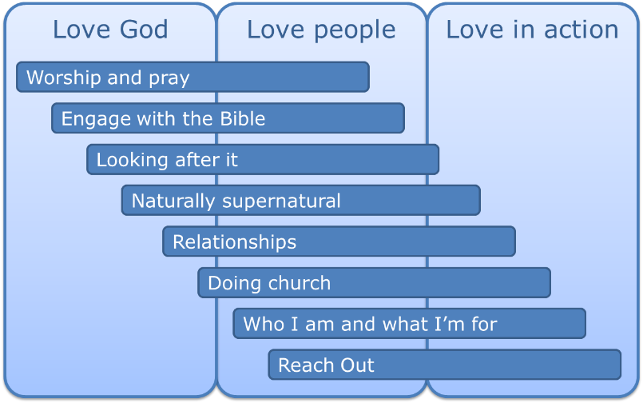
A follower of Jesus nurtures a personal intimacy with the Lord throughout the day and sets time aside regularly for relationship with Him through worship and prayer

The outcomes we see in the lives of people following Jesus will vary, but might include:
- setting aside regular time to interact with God through
  - Suppressing the multi-media flood of information and distraction
  - Bible meditation
  - Bible reading
  - Listening to or playing worship music
  - Talking to God in prayer
  - Prayer structures
  - Journalling
  - Creative arts
  - Liturgies for personal use
  - Fasting
  - Listening to bible-based talks as podcasts while travelling
  - Small and large group events
  - Retreats and festivals
- nurturing personal intimacy with the Lord throughout the day by
  - Practising the presence of God in the "times between times"
  - Having a set of reminders to pray in your daily environment
  - Calling to mind God's priorities in each situation
  - Frequently asking God what he is doing in each situation
- describing specific interactions with God to other individuals inside and outside the church, and in group settings
A follower of Jesus engages with and applies the Bible for all its worth

The outcomes we see in the lives of people following Jesus will vary depending on age, ability and opportunity, but might include (but unlikely to be all of):
- Using daily Bible notes
- Reading a "daily Bible" or using a Through the Bible in a Year plan
- Reading large chunks of Scripture in a modern translation, regularly or periodically
- Listening to the Bible being read on their iPod
- Hearing the Scriptures explained in weekly worship, in housegroup talks or on podcasts
- Discussing how to live out the Bible in a small group setting
- Lectio divina or other forms of Bible meditation (e.g. the Jesuit website)
- Scripture memory programmes
- Calling to mind and/or speaking out scripture in daily life circumstances
- Including appropriate quotes from the Bible in conversation
- Creative arts or crafts that use or reflect on scripture
- Reading commentaries or other books that explain parts of the Bible
- Watching movies like Jesus/MiracleMaker/The Passion and dozens of others that tell the narrative of the Bible
- Attending Bible school lectures, conferences or courses
A follower of Jesus looks after their money, their body, their time, their integrity and the world around

'Looking after it' can be a daunting list, and it is important that these qualities are seen as an attractive vision for living life to the full, rather than a standard for judging others or a personal guilt trip. It is probably not possible to work on every area at once, so each individual will need to listen to God's prompting about what to work on next. The outcomes we see in the lives of people following Jesus will vary, but might include:

Money
Recognising that "it all belongs to God", looking after it might mean:
- Spending less than you earn
- Avoiding consumer debt, or working towards freedom from debt
- Having a financial plan, and a budget
- Saving, and investing in an ethical way
- Giving a proportion of your income
- Generously and spontaneously giving money and other resources to people who need it
- Using money to support and provide for family members
- Making buying decisions with an awareness of fair trade

Body
Recognising that the body is a temple of the Holy Spirit, looking after it might mean:
- Exercising: maintaining a level of fitness
- Resting: getting enough sleep
- Eating: choosing a healthy diet; eating in moderate quantity; being in control of appetite (e.g. learnt through fasting)
- Not being mastered by addictive substances, or working towards recovery from addiction. e.g. alcohol, caffeine, nicotine, prescription drugs, recreational drugs, illicit drugs, substance abuse.
- Sexual expression within an appropriate context, and sexual abstinence outside that context.
- Keeping an active and pure mind: a life-long learner, exploring cultural and artistic expression, in control of your screen use (TV, computer, games), avoiding pornography and excessively violent entertainment

Time
Looking after your time might mean:
- Being organised and disciplined about getting things done efficiently
- Having time to relate to people even when busy
- Setting goals and priorities in prayerful conversation with the Lord
- Protecting time for important things
- Having a regular day off work, being disciplined not to overwork

Integrity
Looking after your integrity might mean:
- Telling the truth
- Being consistent, trustworthy and reliable: sticking to promises and commitments you make
- Able to channel strong emotions (such as anger) in appropriate and non-destructive ways
- Using power and influence for the common good rather than for personal advantage
- Following the radical ethics of Jesus and the law of the land even when it is not convenient
- Staying within the spirit of boundary rules: not gaming the system, not exaggerating claims for benefit, expenses or insurance, not avoiding tax

The world around
Recognising God's mandate to humankind to be stewards of creation, looking after it might mean:
- Reducing waste, reusing, recycling
- Minimising personal impact on planetary resources
- Living out "Godliness with contentment is great gain" and rejecting the consumer quest for more, bigger, better, and newer; and the social pressure to conform to what others are consuming.
- Encouraging and perhaps campaigning for other individuals, corporations and governments to look after creation resources
A follower of Jesus hears from God and prays for people in a naturally supernatural way

The outcomes of being naturally supernatural we see in the lives of people following Jesus will vary, but might include:

- looking out actively to see what the Father is doing in order to join in with it,
- because we know that it is God who acts and
- that he is at work everywhere and all the time - at home, at work, in our neighbourhoods, amongst friends, at weekly worship, on the street, in the train and so on
- taking risks when being prompted by God to do so in order to bring God's love, mercy and grace to people by
- praying for them - their physical/emotional/spiritual health or
- praying for change/transformation in their circumstances or
- sharing a God-given word or picture with them
- using everyday language to talk about what God is doing
- without emotional manipulation or hype,
- assessing change as a result of prayer in a neutral way and
- helping people to deal with disappointment when prayer isn't answered immediately
- surrendering all of our gifts and talents to God for him to use to impact the lives of those who do not know him yet
- so that the whole of our life is infused with the Holy Spirit, we ask the Holy Spirit to impact and transform
- the way we work,
- the way we relate to our families/friends/colleagues/strangers,
- the way we spend our recreation time,
- the way we rest
A follower of Jesus is in increasingly good relationships with everyone they interact with

The outcomes we see in the lives of people following Jesus will vary according to circumstances, but might include:
- Spending quality relationship time with people such as:
  - Close family (parents, siblings, children)
  - Other household members and neighbours
  - Work colleagues
  - Fellow pupils/students
  - People with similar interests or circumstances
  - People in sports and social circles
  - Church people
- Treating tradespeople, retail workers, call centre reps, etc as people not merely functional operatives
- Accepting people for who they are
- Having fun together, hosting parties, celebration, games, humour
- Building friendship
- Speaking highly of people, thinking the best of people, avoiding gossip
- Not being offended easily
- Communicating clearly and sensitively
- Handling conflict well
- Forgiving people with grace and mercy
- Expressing love and demonstrating that you value people (e.g. using the love languages)
- Encouraging and building people up
- Challenging people to grow and develop: coaching, mentoring
- When people ask, holding people accountable to their commitments
- Being single, dating and/or doing marriage well
- Grieving and dealing with loss and bereavement, and helping others through that too

A follower of Jesus participates and engages in church and accountable small group relationships

The outcomes we see in the lives of people following Jesus will vary, but might include:
- A habit of meeting with other Christians regularly
- Participating in worship along with other people
- Active engagement in discussion with other people, as a means of learning and applying the teachings of Scripture to everyday life. "As iron sharpens iron, so one man sharpens another"
- A few people investing significant time in researching and preparing talks to assist the learning of the rest
- Listening to others, and providing acceptance, affirmation, encouragement and emotional support, potentially over an extended period of time
- Vision and motivation for achieving something together that would not be possible as individuals
- Spurring one another on to keep following Jesus more closely
- Working together in teams, and finding synergies between the gifts of different people
- Relating to people of other age groups
- Hospitality: sharing homes, meals and friendship, especially with "people not like us"
- Creating shared memories in the community - milestone events, adventures and story-making that shape our lives
- Shared laughter, fun and joy
- Conflict resolution and advocacy - helping each other to repair relationships
- Mentoring and coaching others as they develop, including adult-adult and appropriately safeguarded adult-young person relationships
- Pioneering new things, with the support of the body of other people
- Corporately employing a number of people to allow the church to be sustained, flourish and develop
A follower of Jesus knows who they are and what they're for and focuses on that

The outcomes we see in the lives of people following Jesus will vary, but might include:
- An increasing sense of personal identity drawn from the Lord as the basis for their self-esteem
- Motivation for service drawn from the "audience of one" and a passion for the themes of the Kingdom of God
- A vision for seeing kingdom themes worked out in their everyday life and work
- Increasing sensitivity to "seeing what the Father is doing and doing that"
- A sense of focus on an area of service based on hearing God's call, and working out what that means in their circumstances and opportunities.
- Acts of practical service that are appropriate for them, based on understanding how he has designed and gifted them as an individual.
- Working as a healthy team with others, understanding their own temperament and strengths, and recognising how others complement that
A follower of Jesus reaches out to people beyond their circle of comfort

Reach Out encompasses a wide range of intentional activities to introduce more people to the Kingdom of God, motivated by gratitude for the mercy God has lavished on us, and with love for each person we meet. Practical activities will vary, according to age, gifting, opportunity and social context. The outcomes we see in the lives of people following Jesus may include some of the following:
- “Walking across the room” i.e. Being alert for people who are new or isolated and willing to leave our own circle of friendship to make a social connection with people we don’t know.
- Doing acts of kindness and friendship i.e. demonstrating the love of God in a practical way, either spontaneously as an individual, or in an organised way as part of a group. Providing resources for acts of kindness.
- Sharing authentic personal stories with a faith element in everyday social situations
- Explaining the story and message of Jesus to those who are ready to listen
- Encouraging people in the practical steps and stages of commitment to following Jesus
- Responding confidently to common challenges to faith in social situations (Giving a reason for the faith that is in you).
- Being alert to the prompting of the Holy Spirit regarding people we meet, and speaking or acting appropriately in response
- Praying with people with all kinds of needs, in informal contexts as well as in meetings
- Finding common purpose with groups of people (e.g. work, social, sport, creative, charitable, social care) and demonstrating kingdom themes in a non-church context
- Inviting/bringing people to appropriate events and activities that introduce them to more Christians and/or aspects of the message of Jesus
- Organising or hosting events and activities (e.g. parties) that connect people with Christians
- Helping in the teams that support this type of event and activity
- Taking part in cross-cultural mission trips
- Supporting cross-cultural mission trips by: praying, providing resources, helping with organisation and communication, championing for the rest of the church
- Using the creative arts to communicate about faith-related topics
- Advocacy: speaking up on behalf of people and social justice, representing them, campaigning on their behalf, mediating conflict
- Exploring new or experimental ways of reaching out

